

Autumn Report

Docker containers deployed using Bluemix

Thomas Flynn

16117743

Sean McGrath

Information & Network Security MEng

2017

Electronic & Computer Engineering

Table of Contents
1 Introduction and report outline 4
1.1 Project description 4
1.2 Project aims and objectives 5
1.3 Report outline 6
1.4 Acronyms 6
2 Literature survey 7
2.1 Outline of research 7
2.2 Docker research 8
2.1 IBM Bluemix 10
IBM Bluemix DevOps Services 12
2.2 Microsoft Azure Container Service 13
2.3 Amazon Container Service 14
2.3 NoSQL Database 15
NoSQL features 15
Common types of NoSQL databases 15
2.5 Neo4j 16
2.6 Neo4j on IBM POWER8 19
2.7 Graph visualization 20
2.8 Programming languages 21
3 Theory 23
3.1 Analytic and theoretical aspects of the project 23
4 High level design 25
4.1 High level design 25
4.2 Software 26
4.3 Process related block 1 26
4.4 Process related block 2 26
4.5 Process related block 3 26
4.6 Process related block 4 26
5 Detailed action plan 27
5.1.1 Spring action plan 27
5.4.2 Summer action planning 29
Summer critical path map 30
6 Discussion 31
6.1 Progress to date 31
6.2 Challenges and risks 31
7 Requirements of facilities and materials 31
8 References 32

1 Introduction and report outline

1.1 Project description
This project aims to provide a bridge between the university’s wireless sensor network (WSN) mobile application and the data mining opportunities of the sensor information obtained. This will comprise of a highly scalable database and a simple web application developed using Docker containers deployed on the cloud.
Docker containers are lightweight self contained Linux Operating systems. They will be used to handle the load balancing aspects of the WSN. The Global Position System coordinates transmitted from the WSN will be stored in a graph database for data mining purposes. The database will need to be a non relational database, allowing the database to scale more efficiently.
The mobile sensor IoT application at this point is still in early development by another student. The application will track the Global Positioning System coordinates of the user when they have stepped onto the university’s campus. This project will allow for a potential survey feature to be implemented in the mobile application. This would provide great data mining capabilities when combined with other sensor data.
The web application will comprise of a simple user interface that will provide the ability to query the sensor data stored in the scalable database. The data will be used to display the current status of the sensors to the user . Graph databases will allow for additional database filtering features to be implemented on the websitenin the later stages of the development life cycle.
In summary this project aims to provide a bridge between WSN and data mining. The learning outcomes of this project will provide me with a foundational knowledge in the areas of security, development and operations in relation to designing highly scalable and secure cloud applications.

1.2 Project aims and objectives

Primary objectives
1.) Create an instance that will transmit pseudo sensor data.
2.) Create an instance that will read sensor data.
3.) Develop a database that can store the pseudo data in an organized manner.
4.) Develop a web application that will display information from the database.
5.) Develop a web server to handle web application database queries.

Secondary objectives
1.) Scale up number of instances.
2.) Test load balancing aspects of increased scale.
3.) End to end testing of application security.

Learning outcomes
1.) Discipline and minimizing procrastination.
2.) Strengthen programming skills.
2.) Development operations.
4.) Application security.

Project summary diagram

1.3 Report outline

Literature survey
Summary of the various aspects of the project such as Docker, Cloud container services vendors, database, and application security research.

Theory
Expands upon in detail the areas discussed in the literature survey.

High level design
Description and diagram of how the multiple project components interact with each other from a high level of abstraction.

Detailed action plan
Describes the project management strategy, critical path, and identified risks.

1.4 Acronyms
MS - Microservice
GPS - Global Positioning System
DB - Databases

2 Literature survey

2.1 Outline of research

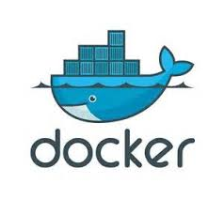
2.1 Docker research

Docker containers
Docker containers wrap a piece of software in a complete file system that contains everything needed to run: code, runtime, system tools, and system libraries. [7]

Lightweight
Containers running on a single machine share the same operating system kernel, they start instantly and use less RAM. Images are constructed from layered filesystems and share common files, making disk usage and image downloads much more efficient. [7]

Open
Docker containers are based on open standards, enabling containers to run on all major Linux distributions and on Microsoft Windows -- and on top of any infrastructure. [7]

Secure by default
Containers isolate applications from one another and the underlying infrastructure, while providing an added layer of protection for the application. [7]

Comparing container and virtual machines
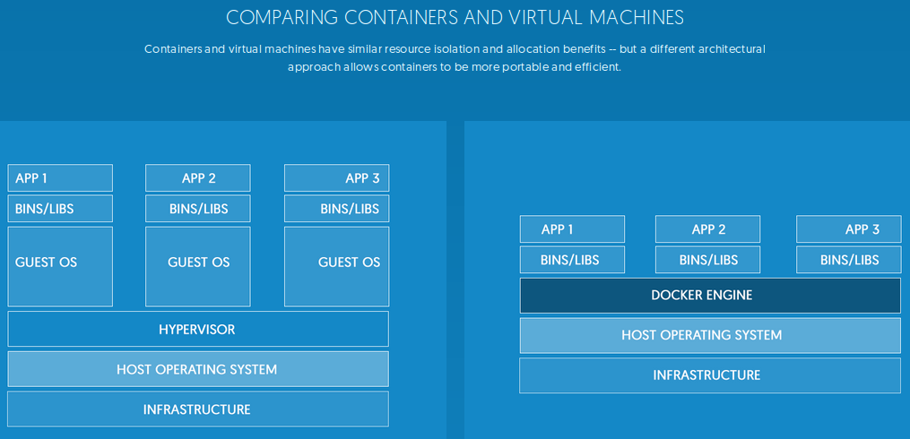

Virtual machines
Virtual machines include the application, the necessary binaries and libraries, and an entire guest operating system -- all of which can amount to tens of Gbs. [7]

Eliminate environment inconsistencies
Packaging an application in a container with its configurations and dependencies guarantees that the application will always work as designed in any environment: locally, on another machine, in test or production. [7]

Quickly scale
Docker containers spin up and down in seconds, making it easy to scale application services to satisfy peak customer demand, and then reduce running containers when demand ebbs. [7]

2.2 IBM Bluemix

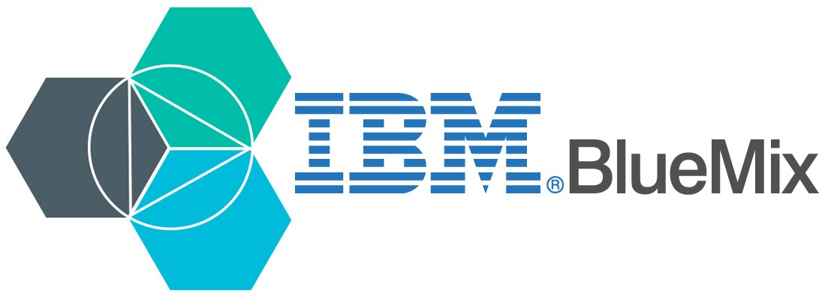
IBM and Docker integrated container solutions
IBM and Docker offer integrated container solutions that can meet the diverse needs of enterprises. Supporting the creation and deployment of multi-platform, multi-container workloads across hybrid infrastructures, IBM and Docker accelerate application delivery and enable application lifecycle management for Dockerized containers. [1]

Create scalable and portable apps and services
Having a hosted container service eliminates the need for users to install, operate and scale container infrastructure meaning they can create containerized applications quickly and easily. Since containers maintain all application configuration settings and dependencies, there is no need to change or reconfigure applications for different environments. Applications can move seamlessly between development, test and production environments. Operations teams can spend less time doing manual installations and troubleshooting issues. [2]

Easily package and deploy applications that will run in hybrid environments
IBM Containers on Bluemix makes it possible to more quickly and easily package and deploy applications that can run across hybrid environments. This technology also makes it possible to run many more applications on the same servers, providing improved resource utilization. [2]

Improve productivity and increase resource utilization
IBM Container users can spin up and tear down standardized environments across development and operations groups faster while increasing application density per server. [2]

Achieve maximum application portability
IBM Containerized applications are seamlessly portable across environments and computing platforms, letting users move them freely to, from and between Linux-based cloud environments. IBM Containers does not add any proprietary code to the Docker engine or registry. [2]

Vulnerability advisor
Discover vulnerabilities and compliance policy problems in Docker images and learn new ways to improve images to meet best practices and upgrades to known industry fixes, regardless of the image source.

Integrated container monitoring
Log visibility and performance insight to the CPU, memory, and network utilization per container.

IBM Bluemix security features
The Bluemix platform secures data-in-transit by securing the end-user access to the application by using SSL through the network until the data reaches IBM DataPower Gateway at the boundary of the Bluemix internal network. IBM DataPower Gateway acts as a reverse proxy and provides SSL termination. From there to the application, IPSEC is used to secure the data as it travels from the IBM DataPower Gateway to the application.
Security for both data-in-use and data-at-rest is your responsibility as you develop your application. You can take advantage of several data-related services available in the Bluemix Catalog to help with these concerns.

Security of Bluemix applications
As an application developer, you must enable the security configurations, including application data protection, for your applications that run on Bluemix.
You can use security capabilities that are provided by several Bluemix services to secure your applications. All Bluemix services that are produced by IBM follow IBM secure engineering development practices.

SSO service
IBM Single Sign On for Bluemix is a policy-based authentication service that provides an easy to embed single sign-on capability for Node.js or Liberty for Java™ applications. To enable an application developer to embed single sign-on capability into an application, the administrator creates service instances and adds identity sources. The Single Sign On service supports several identity sources where your users' credentials are stored:

IBM UrbanCode plug-in for application security testing
The IBM Application Security Testing for Bluemix plug-in enables you to run security scans on your web or Android apps that are hosted on Bluemix. This plug-in is developed and supported by the IBM UrbanCode™ Deploy Community on the IBM Bluemix DevOps Services platform

IBM Bluemix DevOps Services

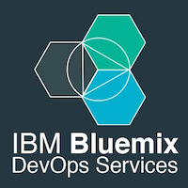
Connect with your GitHub repository
It's easy to link work items with GitHub code changes: use your tools to code, and manage your project with IBM® Bluemix® DevOps Services. You can reference a work item in GitHub comments before you push code changes, and the work item is updated with the new commit information.

Your work in one place
At a glance, see the projects that you own, belong to, and like. You can also see requests to join your project and invitations for you to join other projects. Just another way to help you stay organized.

Built-in source code management
Easily deliver code and seamless track changes from all developers. Each project gets a Git repository or a Jazz source code management repository and workspace where project members check in changes, associate code changes with work items, and view a history of recent updates.

Integrated source code editor
The Web IDE provides features to support these tasks:
- Import your source code.
- Copy a file by dragging it to a new directory.
- Edit code quickly. The editor includes several features:
  - Content assist for CSS, HTML, and JavaScript
  - Syntax highlighting for over 20 popular programming languages
  - Syntax highlighting, validation, and content assist for Cloud Foundry manifest files
  - Code validation
  - Keyboard shortcuts
  - Bracket and block-comment auto-completion
  - Key-bindings for vi and emacs users
  - Quick fixes to automatically solve common programming problems in JavaScript

Work items to track and plan project activities
Track who's doing what, and when it will get done. Need a design? Open a task and assign it to the person who has wireframing tools. Is something not working? Open a defect. Expect to feel great when you complete a work item and change the status to Done.

2.3 Microsoft Azure Container Service

Docker for Azure
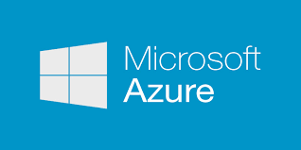
An integrated, easy-to-deploy environment for building, assembling, and shipping applications on Microsoft Azure, Docker for Azure is a native Azure application optimized to take optimal advantage of the underlying Azure IaaS services while giving you a modern Docker platform that you can use to deploy portable apps. Docker for Azure installs a Swarm of Docker Engines secured end to end with TLS by default, and is integrated with Azure VM Scale Sets for autoscaling, Azure Load Balancer and Azure Storage. [3]

Create an optimized container hosting solution
Azure Container Service optimizes the configuration of popular open source tools and technologies specifically for Azure. You get an open solution that offers portability for both your containers and your application configuration. You select the size, the number of hosts, and choice of orchestrator tools, and Container Service handles everything else. [4]

Scale and orchestrate using DC/OS or Docker Swarm
Choose the tools and solution that best suits your needs for Docker container orchestration and scale operations. Use the Mesos-based DC/OS or use Docker Swarm and Compose for a pure Docker experience. [4]

Manage container applications using familiar tools
There’s no need to change your existing management practices to move container workloads to the cloud. Use the application management tools you’re already familiar with and connect via the standard API endpoints for the orchestrator of your choice. [4]

Scale and orchestrate using DC/OS or Docker Swarm
Choose the tools and solution that best suits your needs for Docker container orchestration and scale operations. Use the Mesos-based DC/OS or use Docker Swarm and Compose for a pure Docker experience. [4]

2.4 Amazon Container Service

Docker For AWS

An integrated, easy-to-deploy environment for building, assembling, and shipping applications on AWS, Docker for AWS is a native AWS application optimized to take optimal advantage of the underlying AWS IaaS services while giving you a modern Docker platform that you can use to deploy portable apps. Docker for AWS does not require any software installed. [5]

Amazon EC2 Container Service
Amazon EC2 Container Service (ECS) is a highly scalable, high performance container management service that supports Docker containers and allows you to easily run applications on a managed cluster of Amazon EC2 instances.[6]

Flexible Container Placement
Amazon ECS is a shared state, optimistic concurrency system that supports multiple schedulers on the same cluster for each business or application-specific requirement.[6]

Performance at Scale
Amazon EC2 Container Service is built on technology developed from many years of experience running highly scalable services. You can launch tens or tens of thousands of Docker containers in seconds using Amazon ECS with no additional complexity.[6]

Secure
Amazon EC2 Container Service launches your containers on your own EC2 instances. No compute resources are shared with other customers. Your clusters run in a VPC allowing you to use your own VPC security groups and network ACLs. [6]

Extensible
Amazon EC2 Container Service can easily be integrated or extended through simple APIs. Amazon ECS provides complete visibility and control into your AWS resources, so you can easily integrate and use your own schedulers or connect Amazon ECS into your existing software delivery process.

2.5 NoSQL Database
A NoSQL database provides a mechanism for storage and retrieval of data which is modeled in means other than the tabular relations used in relational databases.

NoSQL features
1. The ability to horizontally scale “simple operation” throughput over many servers,
2. The ability to replicate and to distribute (partition) data over many servers.
3. Simple call level interface or protocol (in contrast to SQL binding),
4. Efficient use of distributed indexes and RAM for data storage
5. The ability to dynamically add new attributes to data records.

Common NoSQL database types:

Document store
Documents are addressed in the database via a unique key that represents that document. One of the other defining characteristics of a document-oriented database is that in addition to the key lookup performed by a key-value store, the database offers an API or query language that retrieves documents based on their contents.

Key value store
Data is represented as a collection of key-value pairs, such that each possible key appears at most once in the collection. The key-value model is one of the simplest non-trivial data models, and richer data models are often implemented as an extension of it. The key-value model can be extended to a discretely ordered model that maintains keys in lexicographic order.

Graph
This kind of database is designed for data whose relations are well represented as a graph consisting of elements interconnected with a finite number of relations between them. The type of data could be social relations, public transport links, road maps or network topologies.

2.6 Graph databases

Graphs are the most efficient and intuitive way of working with data, mimicking the interconnectedness of ideas in the human mind. Neo4j is built from the ground up to harness the power of graphs for real-time, bottom-line insights.

Graph databases
Graph databases are based on graph theory. Graph databases employ nodes, edges and properties.
- Nodes represent entities such as people, businesses, accounts, or any other item you might want to keep track of. They are roughly the equivalent of the record, relation or row in a relational database.
- Edges, also known as graphs or relationships, are the lines that connect nodes to other nodes; they represent the relationship between them.
- Properties are pertinent information that relate to nodes.

Neo4j

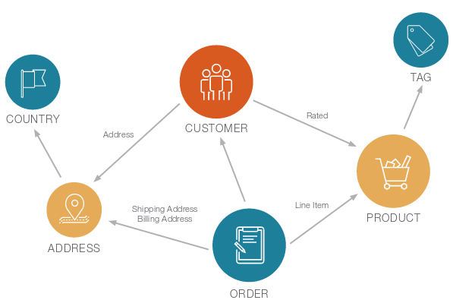

Neo4j vs Relational Databases

Category | Relational Database | Neo4j, Native Graph Database
Data Storage | Storage in fixed, pre-defined tables with rows and columns with connected data often disjointed between tables, crippling query efficiency. | Graph storage structure with index-free adjacency results in faster transactions and processing for data relationships.
Data Modeling | Database model must be developed with modelers and translated from a logical model to a physical one. Since data types and sources must be known ahead of time, any changes require weeks of downtime for implementation. | Flexible, "whiteboard-friendly" data model with no mismatch between logical and physical model. Data types and sources can be added or changed at any time, leading to dramatically shorter development times and true agile iteration.
Query Performance | Data processing performance suffers with the number and depth of JOINs (or relationships queried). | Graph processing ensures zero latency and real-time performance, regardless of the number or depth of relationships.
Query Language | SQL: A query language that increases in complexity with the number of JOINs needed for connected data queries. | Cypher: A native graph query language that provides the most efficient and expressive way to describe relationship queries.
Transaction Support | ACID transaction support required by enterprise applications for consistent and reliable data. | Retains ACID transactions for fully consistent and reliable data around the clock – perfect for always-on global enterprise applications.
Processing at Scale | Scales out through replication and scale up architecture is possible but costly. Complex data relationships are not harvested at scale. | Graph model inherently scales for pattern-based queries. Scale out architecture maintains data integrity via replication. Massive scale up possibilities with IBM POWER8 and CAPI Flash systems.
Data Center Efficiency | Server consolidation is possible but costly for scale up architecture. Scale out architecture is expensive in terms of purchase, energy use and management time. | Data and relationships are stored natively together with performance improving as complexity and scale grow. This leads to server consolidation and incredibly efficient use of hardw

2.7 IBM Cloudant
IBM Cloudant is a managed NoSQL JSON database service built to ensure that the flow of data between an application and its database remains uninterrupted. Developers are then free to build more, grow more and sleep more.

Global availability: Improve your app’s performance
Cloudant’s horizontal scaling architecture can handle millions of users and terabytes of data to grow seamlessly alongside your business.
Users are connected to the closest copy of the data, which reduces data access latency caused by cloud network overhead.

Data flexibility: JSON data store
Cloudant’s RESTful API makes every document in your database accessible as JSON. It is also compatible with Apache CouchDB™, enabling you to access an abundance of language libraries and tools.
Schema flexibility makes Cloudant an excellent fit for multi-structured data, unstructured data and fast-changing data models.

Mobile sync libraries: Develop offline-first apps
Cloudant includes mobile sync libraries for both iOS® and Android™. Offline-first applications built with Cloudant Sync provide a better, faster user experience — both offline and online.
Mobile sync libraries enable your devices to store and access data locally, and then synchronize this data with the cloud when an Internet connection is available.

Advanced APIs: Integrated geospatial operations and search
Enhance web and mobile apps with geospatial operations that go beyond simple bounding boxes.
Seamlessly integrate web and mobile apps with fast, scalable, full-text Lucene indexing and search.

2.x IBM build & deploy pipeline

2.x Cloud foundry

2.x IBM Watson IoT Platform

About Watson IoT platform
Watson IoT Platform provides powerful application access to IoT devices and data to help you rapidly compose analytics applications, visualization dashboards, and mobile IoT apps. Watson IoT Platform allows you to perform powerful device management operations, and store and access device data, connect a wide variety of devices and gateway devices. Watson IoT Platform provides secure communication to and from your devices by using MQTT and TLS.

About Node-RED
Node-RED is a tool for wiring together hardware devices, APIs, and online services in new and interesting ways. You can use Node-RED to create a simulated thermostat that sends simulated data to your Watson IoT Platform service. You can create cards to display real-time data in the Watson IoT Platform dashboard.

2.7 Graph visualization

Alchemy.js Open Source Graph Visualization
As you’ve just seen, preparing, converting and rendering graph data with plain D3 force layout involves a bit of work. The open-source Alchemy.js libraryreplaces this effort with a few lines of configuration. It uses the GraphJSON format for interaction which is easier to handle than the raw D3 JSON format. Alchemy.js is mostly configuration based but can also be customized with javascript functions. It supports custom styling, highlighting, hoover effects, clustering and interactive exploration.

Linkurious Graph Visualization
Linkurious uses Neo4j’s graph database technology to offer you an easy solution to store, search and visualize graphs. You can start navigating inside your graph database. Search for properties, inspect nodes, and explore their relationships visually in your web browser. find any node in your database easily thanks to our built-in search engine. You can simply modify, add and remove nodes or relationships. You can also customize what is displayed, how the data is indexed.

Keylines Graph visualization
KeyLines is an out-of-the-box JavaScript solution for visualizing networks. How and where you get the data is up to you. KeyLines does the job of rendering it and responding to user interactions like clicking, touching, moving nodes, and more. You bind to these events to customize what happens, and, most importantly, your data stays under your control at all times: KeyLines is self-contained and needs no external connections.

2.8 Programming languages

NodeJS
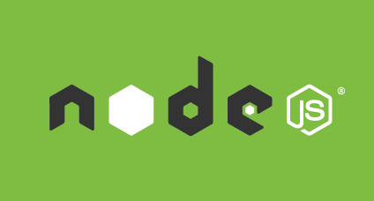
As an asynchronous event driven JavaScript runtime, Node is designed to build scalable network applications. Upon each connection the callback is fired, but if there is no work to be done Node is sleeping. This is in contrast to today's more common concurrency model where OS threads are employed. Thread-based networking is relatively inefficient and very difficult to use. Furthermore, users of Node are free from worries of dead-locking the process, since there are no locks. Almost no function in Node directly performs I/O, so the process never blocks. Because nothing blocks, scalable systems are very reasonable to develop in Node.


Angular JS
AngularJS lets you write client-side web applications as if you had a smarter browser. It lets you use good old HTML as your template language and lets you extend HTML’s syntax to express your application’s components clearly and succinctly. It automatically synchronizes data from your UI (view) with your JavaScript objects (model) through 2-way data binding. To help you structure your application better and make it easy to test, AngularJS teaches the browser how to do dependency injection and inversion of control.


Java
Java is a general-purpose computer programming language that is concurrent, class-based, object-oriented, and specifically designed to have as few implementation dependencies as possible.


Perl
Perl 5 is a highly capable, feature-rich programming language with over 29 years of development. Perl 5 runs on over 100 platforms from portables to mainframes and is suitable for both rapid prototyping and large scale development projects.


PHP
What distinguishes PHP from something like client-side JavaScript is that the code is executed on the server, generating HTML which is then sent to the client. The client would receive the results of running that script, but would not know what the underlying code was. You can even configure your web server to process all your HTML files with PHP, and then there's really no way that users can tell what you have up your sleeve.

2.9 REST API

3 Theory

3.1 Analytic and theoretical aspects of the project

3.2 Bluemix services

Geospatial Analytics service
Expand the boundaries of your application. Leverage real-time geospatial analytics to track when devices enter, leave or hang out in defined regions. Powered by IBM Streaming Analytics on Bluemix.
Features
-Monitor device locations in real-time.
-Connect to data sources that support the MQTT protocol and monitor devices as they move into geographic regions of interest.
-Control region monitoring using the geospatial API.
-Define geographic regions and control monitoring of regions using the geospatial application programming interface.

IBM Graph service
IBM Graph is an easy-to-use, fully-managed graph database service for storing and querying data points, their connections, and properties. IBM Graph offers an Apache TinkerPop3 compatible API and plugs into your Bluemix application seamlessly. This service can be used for building recommendation engines, analyzing social networks, and fraud detection.

Features
Highly Available
Architected to ensure the service is always up and your data is always accessible.
Scale Seamlessly
Start small and scale on-demand as your data grows.
Managed 24x7
Stack is monitored, managed, and optimized by experts 365 days a year.
Powered by Apache TinkerPop3
IBM Graph is based on the TinkerPop stack for building high-performance graph applications.

 | Plan | Features | Pricing
 | Standard | - 500 MB of free data storage  - 25,000 API calls free per month | - $15.00 USD/GB  - $0.20 USD/1000 API Calls

Auto-Scaling service
The Auto-Scaling for Bluemix service enables you to automatically increase or decrease the compute capacity of your application. The number of application instances are adjusted dynamically based on the Auto-Scaling policy you define.
Features
Dynamic scaling
Automatically add or remove resources to match the current workload.
Custom scaling policy
Define policy on metrics of interest.
Metric statistics
Visualize the current and historical values of performance metrics.
Scaling history
Query the scaling activities based on status, time and type.

Load Impact service
Worlds #1 load testing tool - trusted by over 120,000 developers and testers. Unlimited testing, on-demand from multiple geographic locations. Create sophisticated tests using our simple GUI or connect directly to our platform via our API.

- Max 100 concurrent users (VUs) per test
- 5 tests per month
- Max 5 minutes test duration
- Max 1 server metric agents

IBM Bluemix and POWER8 configuration example
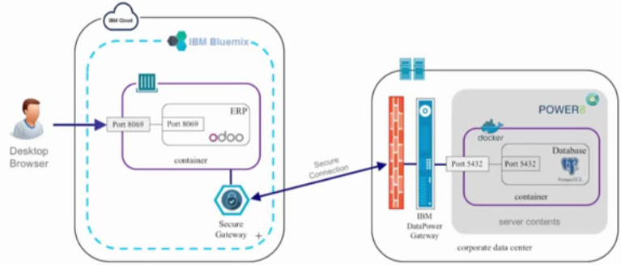
The above figure demonstrates an example of an IBM container running within IBM Bluemix (left hand side) connecting to a database running within a Docker container that is deployed with IBM’s POWER8 (right hand side). The IBM container is linked with the secure gateway service which helps provide a secure connection to the database.
To connect to the database you have to go through 2 layers. The first is a firewall. The second is the IBM DataPower gateway which will make a connection with the secure gateway on the Bluemix side. Behind these 2 layers is the POWER8 system which is hosting the Docker environment.

IBM DataPower Gateway

IBM Secure Gateway Service

4 High level design

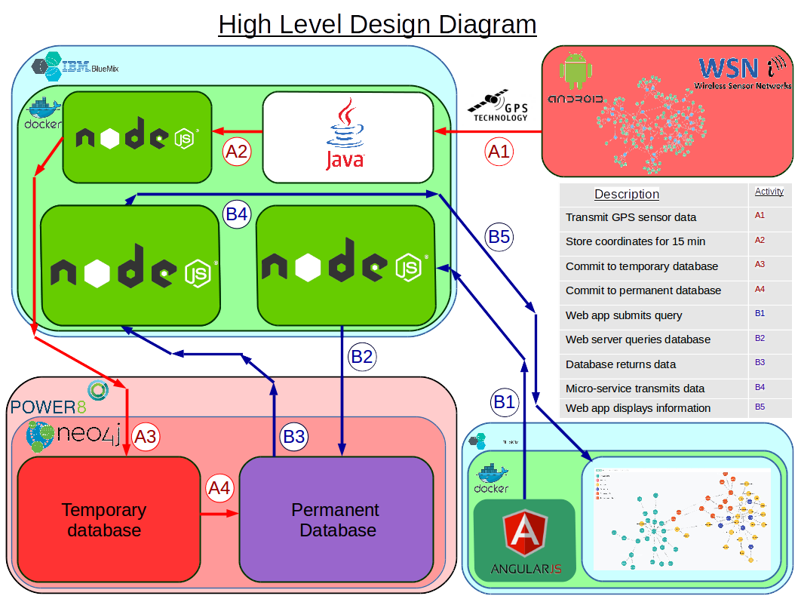
4.1 High level design

4.2

4.2 Software

4.3 Process related block 1

4.4 Process related block 2

4.5 Process related block 3

4.6 Process related block 4

5 Detailed action plan

5.1.1 Spring action plan

Table of tasks for Spring semester
Task Description | Task Identity | Duration  (days) | Preceding Task
Research similar microservices | JA1 | 5
Research Gremlin | JA2 | 5
Research IBM graph examples | JA3 | 5 | JA2
Deploy and run MS1 that creates and transmits pseudo sensor data | JA4 | 5 | JA1
Deploy and run MS2 that handles incoming data | FE1 | 5 | JA4
Deploy a basic graph database on IBM graph with suitable pseudo data | FE2 | 5 | JA3
Research Bluemix website deployment examples | FE3 | 3
Deploy a basic website on Bluemix | FE4 | 3 | FE3
Create permanent graph DB on POWER8 | FE5 | 5 | FE4
Create temporary DB on POWER8 | FE6 | 5 | FE5
Develop code for MS2 to store incoming data for a short period of time | MAR1 | 5 | FE1
MS2 writes to temporary database every 15 minutes | MAR2 | 5 | MAR1 & FE6
MS3 reads data from temporary database | MAR3 | 5
MS3 writes to permanent POWER8 database | MAR4 | 5 | MAR3
Develop map user interface for website | APR1 | 5 | FE4
Identify important UL GPS coordinates for map user interface | APR2 | 5 | APR1
Develop code for website to submit a simple database request | APR3 | 5 | APR2
MS4 handles a simple website client database request | APR4 | 5 | APR3 & MAR4

Critical path map
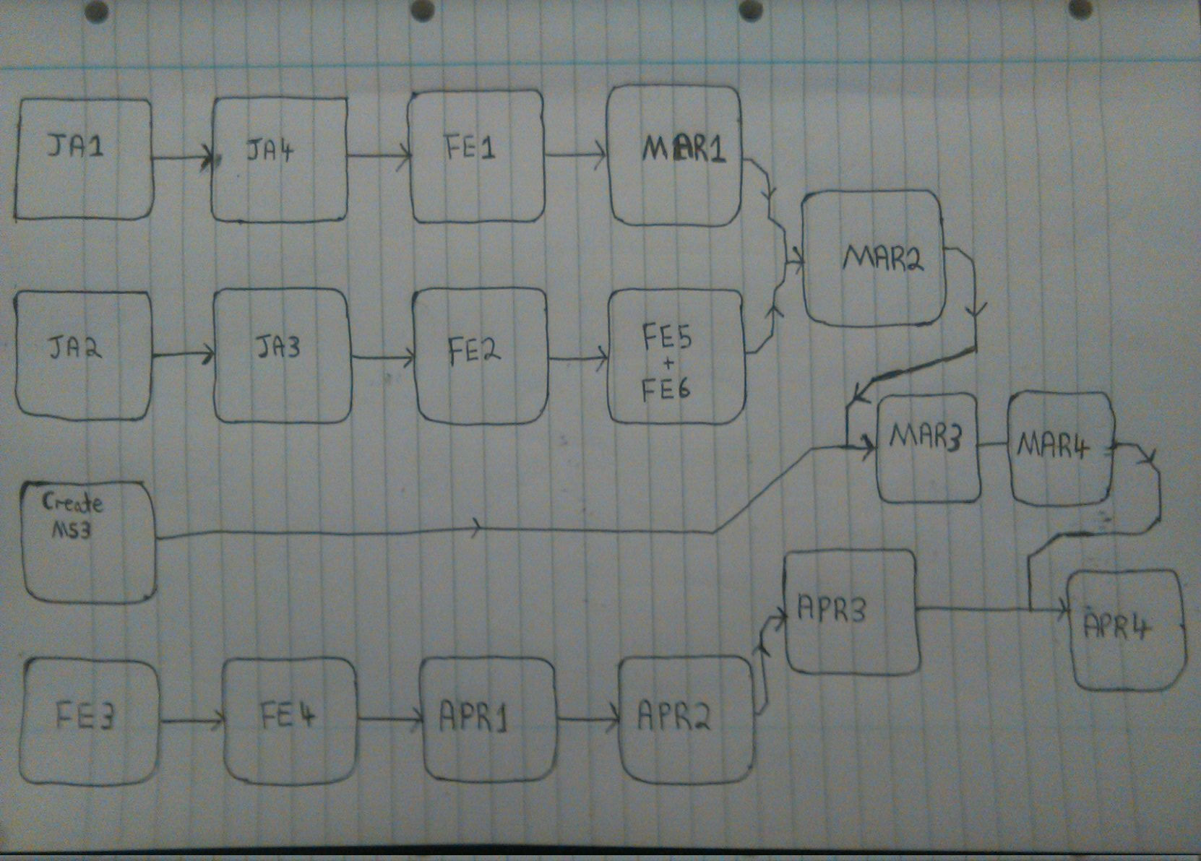

Spring Gantt chart
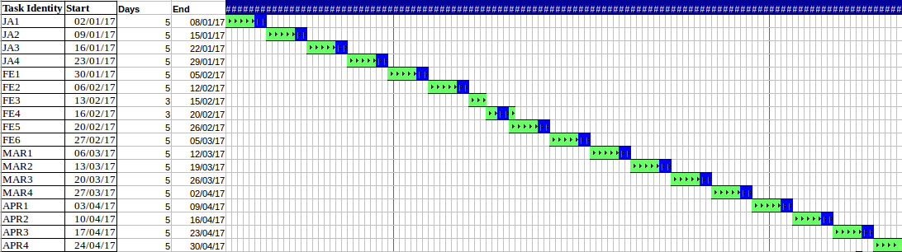

5.4.2 Summer action planning

Table of tasks for Summer semester
Task Description | Task Identity | Duration | Preceding Task
Website displays DB readings on website map user interface | MAY1 | 5 | APR4
Load balancing and scalability research | MAY2 | 5
Increase funding | MAY3 | 5
Increase MS1 instances | MAY4 | 5 | MAY3
MS2 Automatically handles increase/decrease of incoming sensor data from MS1 | MAY5 | 5 | MAY2 & MAY 4
Test scalability of MS2 writing to temporary database | JUN1 | 9 | MAY1 & MAY 5
Test scalability of MS3 reading from temporary database and writing to permanent database | JUN2 | 8 | JUN1
End to end testing of website and permanent database under increased scale | JUN3 | 3 | JUN2
End to end testing of the whole system | JLY1 | 4 | JUN3
Collect results | JLY2 | 2 | JLY1
Analyze results | JLY3 | 3 | JLY2
Discuss results with supervisor | JLY4 | 3 | JLY3
Write up initial report and submit to supervisor for review | JLY5 | 3 | JLY4
Edit initial report | JLY6 | 3 | JLY5

Summer critical path map
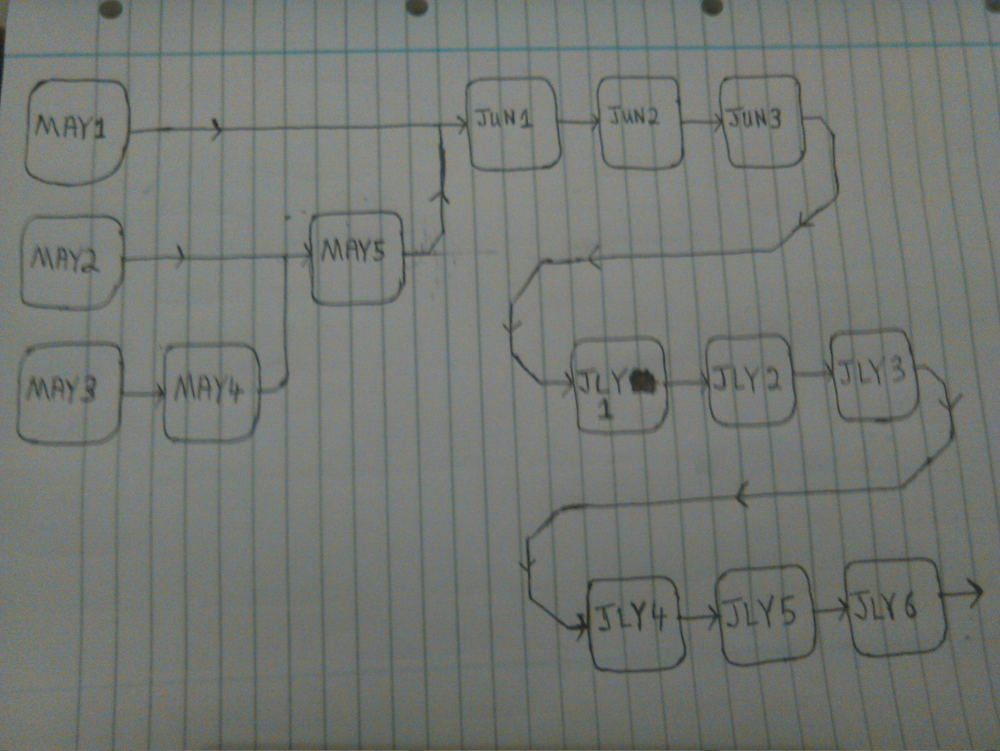
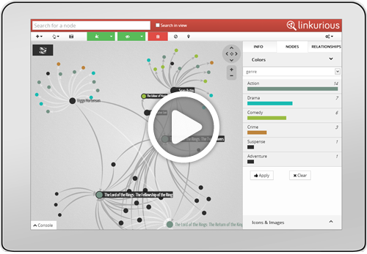

Summer Gantt chart

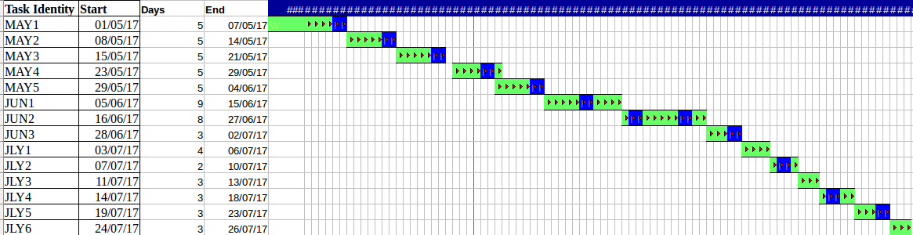

6 Discussion

6.1 Progress to date

6.2 Challenges and risks

7 Requirements of facilities and materials

8 References
[1]"IBM", Docker, 2015. [Online]. Available: https://www.docker.com/IBM. [Accessed: 14- Oct- 2016].
[2]"IBM Bluemix - Containers", Ibm.com, 2016. [Online]. Available: http://www.ibm.com/cloud-computing/bluemix/containers/. [Accessed: 14- Oct- 2016].
[3]"Microsoft", Docker, 2015. [Online]. Available: https://www.docker.com/microsoft. [Accessed: 14- Oct- 2016].
[4]"Azure Container Service | Microsoft Azure", Azure.microsoft.com, 2016. [Online]. Available: https://azure.microsoft.com/en-us/services/container-service/. [Accessed: 14- Oct- 2016].
[5]"Get Started with Docker and AWS", Docker, 2015. [Online]. Available: http://www.docker.com/aws. [Accessed: 14- Oct- 2016].
[6]"Amazon EC2 Container Service – Docker Management – AWS", Amazon Web Services, Inc., 2016. [Online]. Available: https://aws.amazon.com/ecs/. [Accessed: 14- Oct- 2016].
[7]"What is Docker?", Docker, 2015. [Online]. Available: https://www.docker.com/what-docker. [Accessed: 14- Oct- 2016].
[8]"IBM Bluemix Docs", Console.ng.bluemix.net, 2016. [Online]. Available: https://console.ng.bluemix.net/docs/services/graphdb/index.html. [Accessed: 15- Oct- 2016].
[9]"IBM Graph - API", Ibm-graph-docs.ng.bluemix.net, 2016. [Online]. Available: https://ibm-graph-docs.ng.bluemix.net/api.html. [Accessed: 15- Oct- 2016].
[10]"GremlinDocs", Gremlindocs.spmallette.documentup.com, 2016. [Online]. Available: http://gremlindocs.spmallette.documentup.com/. [Accessed: 15- Oct- 2016].
[11]A. TinkerPop, "Apache TinkerPop", Tinkerpop.apache.org, 2016. [Online]. Available: https://tinkerpop.apache.org/. [Accessed: 15- Oct- 2016].
[12]"Neo4j on IBM POWER8® - Neo4j Graph Database", Neo4j Graph Database, 2016. [Online]. Available: https://neo4j.com/neo4j-on-ibm-power8/. [Accessed: 15- Oct- 2016].
[13]"Neo4j Graph Database: Unlock the Value of Data Relationships", Neo4j Graph Database, 2016. [Online]. Available: https://neo4j.com/product/. [Accessed: 15- Oct- 2016].
[14]"Implementing a Containers-based Hybrid Cloud ERP environment using IBM Bluemix", YouTube, 2016. [Online]. Available: https://www.youtube.com/watch?v=9XbzUqCvl3I. [Accessed: 15- Oct- 2016].
[15]"Neo4j Spatial: Finding Things Close to Other Things - Neo4j Graph Database", Neo4j Graph Database, 2011. [Online]. Available: https://neo4j.com/blog/neo4j-spatial-part1-finding-things-close-to-other-things/. [Accessed: 15- Oct- 2016].
[16]R. Catell, "Scalable SQL and NoSQL Data Stores", 2016. [Online]. Available: http://www.cattell.net/datastores/Datastores.pdf. [Accessed: 16- Oct- 2016].
[17]N. Staff, "Neo4j 2.2.0 – Massive Write & Read Scalability, Faster Cypher Query Performance, Improved Developer Productivity - Neo4j Graph Database", Neo4j Graph Database, 2015. [Online]. Available: https://neo4j.com/blog/neo4j-2-2-0-scalability-performance/. [Accessed: 16- Oct- 2016].
[20]T. Shields, "The Forrester Wave™: Application Security, Q4 2014", Forrester.com, 2016. [Online]. Available: http://www.forrester.com/pimages/rws/reprints/document/109101/oid/1-ZHIZ47. [Accessed: 20- Oct- 2016].

